

Mr. Joydeep Patar

Object Oriented Programming - Python
Chepter II - Functions

Assistant Professor Department of Computer Engineering
Dayananda Sagar University

September 8, 2025

Introduction

1

Advantages of using Function

2

Function Definition

3

Function Definition: Example

4

Calling a Function

5

Examples

6

A function is a block of reusable code that performs a specific task.

Types of Functions
Built-in Function – print(), len(), max() etc. User-defined Function

Code Reusability
- Write once and reuse the same code wherever required.

Modularity
- Breaks a large program into smaller, manageable parts.

Improved Readability
- Function names and structures make code easier to read.

Easy Testing and Debugging
- Functions can be tested individually to isolate issues.

Avoids Repetition
- Reduces code duplication, saving development time.

def

Syntax:
Python Function Syntax

Function Body

Parameters

Function Name

return (optional)

# Colon starts function body
def function name(parameters):
# function body
return value (optional)

def → Keyword to define a function
Python Code

# Function definition starts with ’def’
# Function body
# Return statement (optional)
def add_numbers(a, b):
result = a + b return result
add numbers → Function name
a, b → Parameters
: → Indicates the start of function body
return result → Returns the output of the function

Syntax:
Key Point

A function runs only when it is called. It does **not** execute on its own.
function name()
function name(arg1, arg2, ...)

Examples:
add()
add(20)
add(10.56, 34)

Example: 1

def check(x):
if x % 2 == 0: return "Even"
else:
return "Odd"

Question: What will be the output of check(13)?

Options:
- Even
- Odd
- Error
- None

Example: 2

def square(x):
return x * x def add one(y):
return y + 1

Question: What will be the output of the expression square(add one(3))?

Options:
- 9
- 10
- 16
- 25

Example: 3

def check sum prime(a, b):
def is prime(n): if n < 2:
return False
for i in range(2, int(n**0.5) + 1): if n % i == 0:
return False return True
total = a + b print("Sum:", total) if is prime(total):
print("It is Prime") else:
print("It is Not Prime") check sum prime(8, 5)

What is the output?
- Sum: 13
It is Prime
- Sum: 13
It is Not Prime
- Sum: 12

1
def add_sub ( y):
x = 10
c = x + y
d = y - x return c, d
sum , sub = add_sub (20) print( sum )
print( sub )
2
3
4
5
6
7
8
9

No Return Value
Returns None by default.

1
def say_hello ():
print(" Hello ")
2

Return Single Value

1
def square ( x):
return x * x
2

Return Expression

1
def calc(x, y, z):
return x * y + z
2

Return Multiple Values (Tuple)
def operations (a, b):
return a + b, a - b
1
2

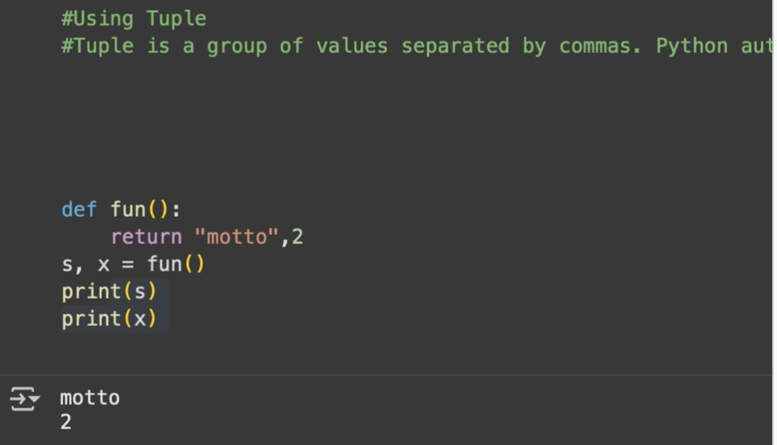

Return List / Dict / Set

1
def get_students ():
return [" Alice ", " Bob "]
def get_profile ():
return {" name ": " John ", " age ": 22}
2
3
4
5

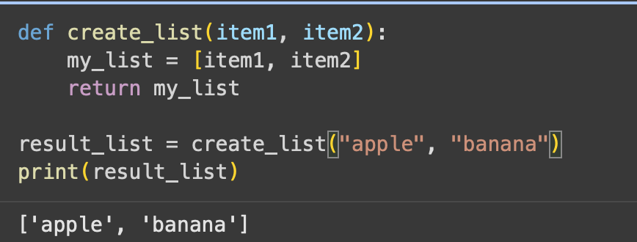

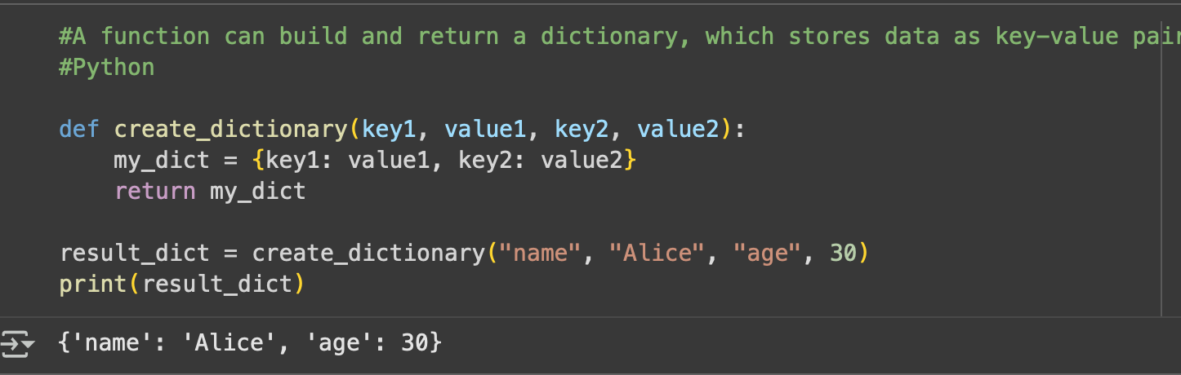

Conditional Return
def sign ( x):
if x > 0:
return " Positive " else :
return " Non - positive "
1
2
3
4
5

Return Function (Closure)

1
def outer ():
def inner ():
return " Inner" return inner
2
3
4

Return Lambda

1
def multiplier ( n):
return lambda x: x * n
2

Return Object

1
class Student:
pass
def get_student (): return Student ()
2
3
4
5

A nested function is a function defined inside another function. It can access variables from the enclosing (outer) function.

Example:
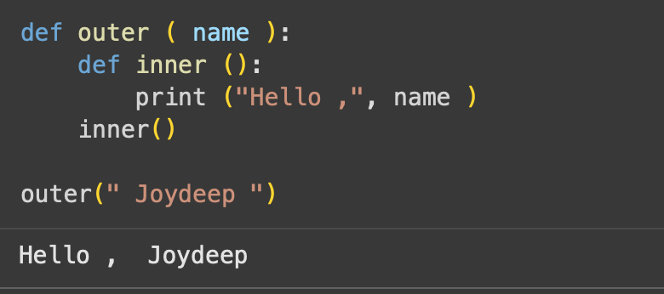

Output:
Hello, Joydeep

In Python, functions are first-class objects.
This means functions can be passed as arguments to other functions.
Useful for callbacks, higher-order functions, and functional programming.

Example: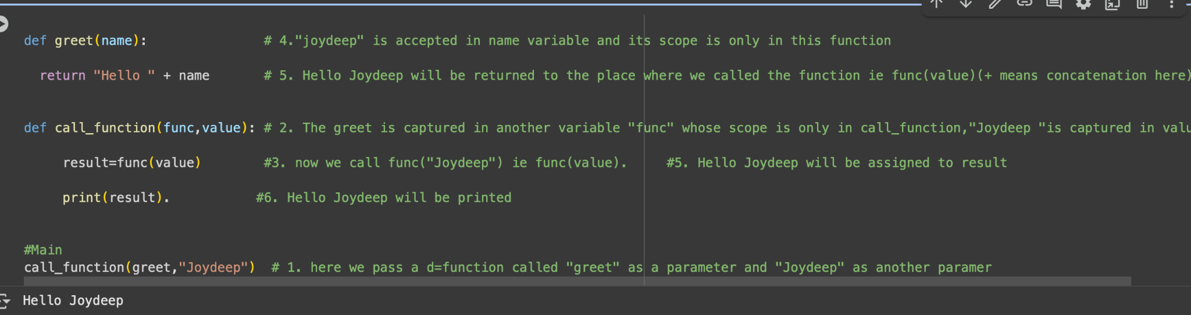

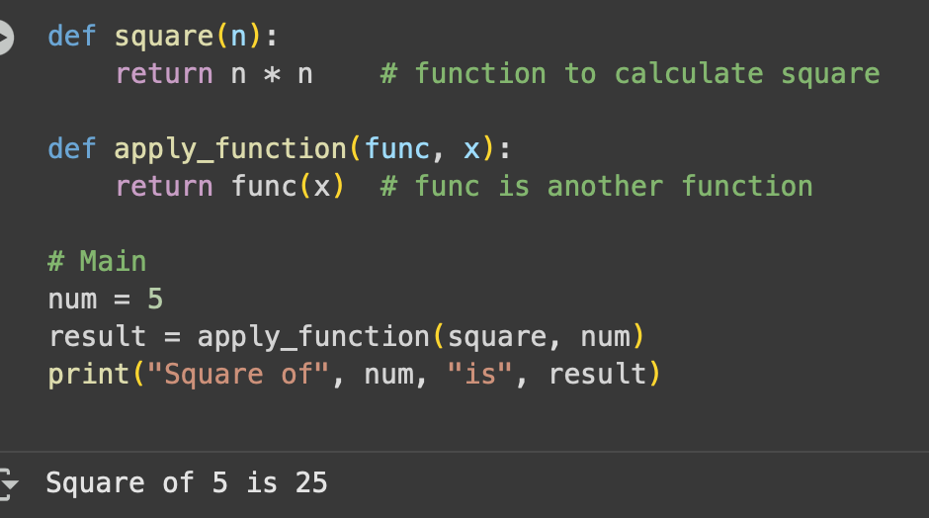

In Python, functions can return other functions.
This allows for powerful design patterns like closures and decorators.

Example:
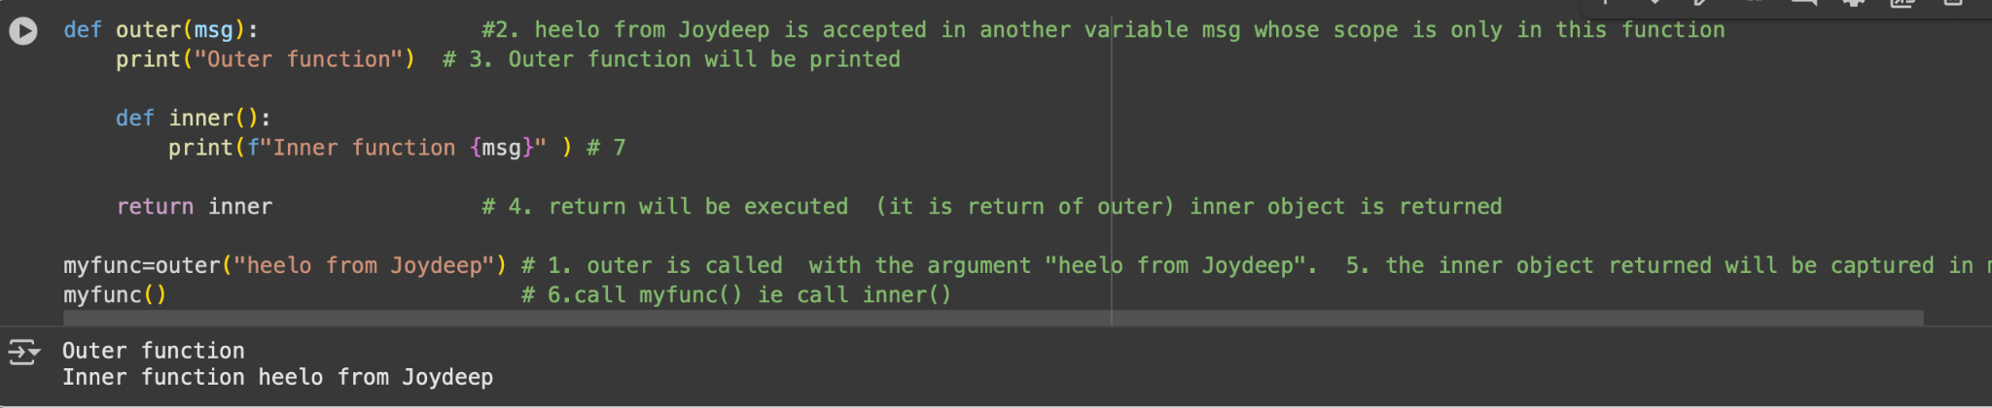

Output: Message: Hello from Joydeep

Formal Parameters: Variables defined in the function definition that accept the values passed.
Actual Parameters: Real values or variables passed to the function when it is called.
Used for: Data transfer between function call and definition.

Example:

1

def greet( name ):
# ’ name ’ is a formal parameter
print(" Hello ,", name )
greet(" Joydeep ")
# " Joydeep " is an actual parameter
2
3
4

Output: Hello, Joydeep

Positional Arguments Keyword Arguments Default Arguments
Variable Length Arguments
Keyword Variable Length Arguments

Arguments are passed in the order defined in the function.

Example:

1
def multiply (a, b):
print(" Product:", a * b)
multiply (5 , 3)
2
3
4

Output: Product: 15

Arguments passed using parameter names.

Example:

1
def subtract(a, b):
print(" Result:", a - b)
subtract( b=10 , a =25)
2
3
4

Output: Result: 15

If no value is passed, the default is used.

Example:

1
def power( base , exponent =2):
print(" Power:", base ** exponent)
power (5) # uses default exponent = 2 power (2 , 3) # overrides default
2
3
4
5

Output:
Power: 25
Power: 8

Accepts multiple integers as positional arguments.

Example:

1
def total_sum (* nums):
print(" Sum :", sum ( nums))
total_sum (5 , 10 , 15)
2
3
4

Output: Sum: 30

Accepts any number of integer values with keys.

Example:

1
def marks (** scores):
for subject , mark in scores. items (): print( f"{ subject }: { mark}")
marks( Math =95 , English =88 , Science =92)
2
3
4
5

Output:
Math: 95
English: 88
Science: 92

Create a function in Python.

1
Create a function with variable length of arguments. Return multiple values from a function.

2

3
Create a function with a default argument.

4
Create an inner function to calculate the addition in the following way. Create a recursive function.

5

6
Assign a different name to a function and call it through the new name.

7

Definition:
Global Variable: Declared outside any function, accessible throughout the program.
Local Variable: Declared inside a function, accessible only within that function.

Example:

1

x = 10
# Global Variable
def calculate ():
x = 5
y = 2
z = x + y
# Local Variable ( shadows global x)
#
Uses local x
print(" z =", z)
calculate ()
print(" x =", x) # Uses global x
2
3
4
5
6
7
8
9
0

Note:
Local and global variables can have the same name.
Inside the function, Python uses the local variable by default.

Problem: If a local variable and global variable have the same name, the function by default refers to the local variable and ignores the global one.
Solution: Use the global keyword to access and modify the global variable inside a function.

Example:

1
x = 10
def update ():
global x # Accesses global variable x = x + 5
print(" Inside :", x)
update () print(" Outside :", x)
2
3
4
5
6
7
8
9

Explanation:
Without the global keyword, a new local variable x would be created. With global, the original variable is modified.

If a local variable and a global variable have the same name, then the function by default refers to the local variable and ignores the global variable.
This means the global variable is not accessible inside the function, but it is accessible outside the function.
In this situation, if we need to access the global variable inside the function, we can use the
global keyword followed by the variable name.
Without using global
Using global

a = 50
def show():
a = 10
print(a)
show() print("a:", a)
a = 50
def show():
global a print(a) a = 20
print(a)
show() print("a:", a)

The globals() function returns a table of current global variables in the form of a dictionary. It can be used to access a global variable even if a local variable has the same name.
Example

a = 50
def show():
a = 10
print("Local Variable A:", a) x = globals()[’a’]
print("X:", x)
show()
print("Global Variable A:", a)

In languages like C or Java, values are passed by value or by reference. In Python, arguments are passed using object references.
This means:
The reference (address) of the object is passed to the function.
If the object is mutable (e.g., list, dict), changes inside the function affect the original object.
If the object is immutable (e.g., int, str, tuple), changes create a new object, leaving the original unchanged.

Example 1: Immutable Object (Integer)
Code

def val(x):
x = 15
print(x, id(x))
x = 10
val(x)
print(x, id(x))

Explanation:
Integers are immutable.
When x = 15 is executed, a new object is created in memory. The global x remains unchanged (10).

Example 2: Mutable Object (List)
Code

def val(lst):
lst.append(4) print(lst, id(lst))
lst = [1, 2, 3]
print(lst, id(lst)) val(lst)
print(lst, id(lst))

Explanation:
Lists are mutable.
The same object reference is passed to the function.
Adding a new element modifies the same list in memory.

What is Recursion?
A function calling itself again and again.
Used to solve problems by breaking them into smaller sub-problems.

Advantages
Simplifies complex problems.
Easier for sequence generation (e.g., factorial, Fibonacci). Code looks clean and short.

Disadvantages
Uses more memory and time (expensive). Harder to debug.
Sometimes tricky to understand.
With Recursion
Without Recursion

def factorial(n): result = 1
for i in range(1, n+1): result *= i
return result
print(factorial(5)) # 120
def factorial(n): if n == 0:
return 1 else:
return n * factorial(n-1)
print(factorial(5)) # 120

Print the multiplication table of 12 using recursion.
Write a function to calculate the area and perimeter of a rectangle. Write a function to calculate the area and circumference of a circle.
Write a function to calculate the power of a number raised to another. Write a Python function to find the maximum of three numbers.
Write a Python program to convert degrees to radians.

Expression / Expression Statements
Used to compute and return a value, or to call a function. Examples: 2+3, a-b, print("Hello").

Statement
Represents a complete instruction in Python. Can span one or more lines of code.
Expressions are also statements.
Examples: if statement, assignment (x = 5), loops.

Definition
A function without a name is called an Anonymous Function. Also known as a Lambda Function.
Defined using the lambda keyword (not def).

Syntax:
lambda argument list : expression

Examples:
lambda x : print(x) lambda x, y : x + y

Syntax:
lambda argument list : expression

Example:
lambda x, y : x + y

Explanation:
lambda −→ creates an anonymous function.
x, y −→ function arguments.
: −→ separates arguments from the expression.
x + y −→ expression to be returned.

Examples:
# Lambda with one argument sum = lambda x : x + 1 print(sum(5)) # Output: 6
# Lambda with two arguments add = lambda x, y : x + y print(add(5, 2)) # Output: 7

No Name: A Lambda Function doesn’t have any name.
lambda x : print(x)

Returns a Function: A Lambda can be assigned to a variable.
show = lambda x : print(x)

Arguments: A Lambda function can take zero or any number of arguments but contains only one expression.
lambda x, y : x + y

Return Statement: No need to write return — the expression is returned automatically.
Body Restriction: Can only contain expressions (not statements).
Arguments Support: You can use all types of actual arguments (positional, default, variable-length, etc.).

Definition: When we write a lambda function inside another lambda function, it is called a

Nested Lambda Function.

Example:
add = lambda x=10 : (lambda y : x + y)
a = add() # returns inner lambda function print(a) # <function <lambda> ... > print(a(20)) # Output: 30

Concept: We can pass a lambda function as an argument to another function.

Example:
def show(a):
print(a(8))
# Passing lambda function as argument show(lambda x : x) # Output: 8

Concept: A function can return a lambda function as its result.

Example:
def add():
y = 20
return (lambda x : x + y)
a = add() # ’a’ now refers to the returned lambda print(a(10)) # Output: 30

Concept: An IIFE is a function (here, a lambda) that is defined and called immediately without being stored in a variable.

Examples:
# Normal lambda usage sum = lambda x : x + 1
print(sum(5)) # Output: 6
# IIFE with one argument
print((lambda x : x + 1)(5)) # Output: 6
# Normal lambda with two arguments add = lambda x, y : x + y
print(add(5, 2)) # Output: 7
# IIFE with two arguments
print((lambda x, y : x + y)(5, 2)) # Output: 7

A Decorator is a function that adds extra features to another function without changing its code.
A decorator takes a function as input, wraps it inside another function, and returns the new function.
We use the symbol @decorator name before the function definition to apply a decorator.

Key Idea: Decorators let us reuse code (like logging, checking permissions, measuring execution time) by wrapping existing functions.

Placeholder Citation 1, ”Title of Paper 1,” in Placeholder Journal Name, Year, pp. X-Y.

Placeholder Citation 2, ”Title of Paper 2,” in Placeholder Journal Name, Year, pp. X-Y.

